National Health Data Hub Data Breach Response Plan
  - Version as of December 2025

Introduction 2
1. Purpose 3
2. Scope 3
3. Classification of breaches 3
4. Definitions 4
4.1 Incident 4
4.2 Data breach 4
4.3 Privacy breach 4
4.4 S.29 breach/ Confidentiality Undertaking 4
4.5 Eligible data breach 5
4.5 DAT Act (scheme data) breach 5
4.6 Cyber security event 5
4.7 Cyber security incident 5
5. What does a data breach look like? 5
6. Key roles and responsibilities 6
7. Procedures 7
8. Version control 8

Introduction
The National Health Data Hub (NHDH) Data and Privacy Breach Response Plan (Response Plan) is intended for all users of the NHDH. The NHDH Response Plan outlines the steps to be taken by NHDH users when responding to a data breach (whether actual or suspected).
All NHDH users who have signed the AIHW Confidentiality Undertaking are obligated to comply with the Response Plan as part of their responsibilities when accessing and using NHDH data.

Purpose
The NHDH Response Plan outlines AIHW procedures and lines of authority for responding to data breaches (whether actual or suspected), including those involving personal information, in accordance with the Privacy Act 1988 (Cth), the AIHW Act 1987 and Australian Government information security requirements regarding secure handling of data including the Information Security Manual and Protective Security Policy Framework.
The NHDH Response Plan:
- provides guidance to NHDH users on how to rapidly assess, contain and respond to potential data breaches (including those involving a breach of privacy) and mitigate and remediate potential harm to any affected individuals
- clarifies relevant roles and responsibilities in the event of a potential data breach
- provides a flowchart to guide NHDH users when responding to a potential data breach.

Scope
The NHDH Response Plan applies to all NHDH data and information (including statistical data and corporate information, whether in physical or electronic form). It applies to all data breaches, including those involving:
- breaches of conditions of approval e.g. AIHW Act (section 29), ethics committee conditions, or data custodian conditions
- personal information in accordance with the Privacy Act
- AIHW policies and procedures in place to meet regulatory obligations or best practice guidance in relation to data and personal information.
It expands on information on notification of actual or suspected data breaches (including privacy breaches) and requirements in the AIHW’s Policy for the Custody of AIHW Data. The Response plan aligns with the AIHW IT security – plan – cyber security incident response (Cyber security plan). The response to a cyber security incident and a data breach may occur in parallel. Where there is potential for confusion between the two, the NHDH Data and Privacy Breach Response Plan takes precedence.
All other matters are out of scope.

Classification of breaches
Breaches are classified as data breaches by the Privacy Officer or delegate where they fail to comply with:
- NHDH Governance Protocols
- the Privacy Act
- AIHW Act s.29 confidentiality obligations
- AIHW Ethics Committee approval requirements
- legislation other than the Privacy Act or AIHW Act such as:
  - the Queensland Public Health Agreement for sharing Hospital data.
  - Australian Privacy Principles (APPs)
  - public interest certificates
  - data supplier agreements

- other required approvals, e.g. university ethics committee.

Definitions

4.1 Incident
All suspected breaches which activate this response plan and are reported are referred to as “incidents” until they have been assessed by the AIHW Privacy Officer or delegate. They remain incidents (data or privacy incidents) where information may have been subjected to unauthorised access, modification, use or disclosure or other misuse, , but further investigation determines that a breach did not occur. These cases are classified as incidents and recorded because there may be lessons to be learned to prevent future breaches.

4.2 Data breach
A data breach occurs when information is lost or subjected to unauthorised access, modification, use, disclosure, or other misuse. Data breaches can be caused or exacerbated by a variety of factors, affect different types of information, and can lead to potential or actual harm to individuals, agencies, and organisations.

4.3 Privacy breach
A privacy breach is a data breach that involves information from which a person could reasonably be identified.
The definition of ‘reasonably be identified’ aligns with that provided in the Office of the Australian Information Commissioner (OAIC) Australian Privacy Principles guidelines.
Privacy breaches that meet certain criteria are classified as ‘eligible data breaches’ under the Privacy Act.

4.4 Section 29 breach/Breach of Confidentiality Undertaking
A breach of the s29 confidentiality obligations of the AIHW Act is considered a data breach. Examples of these include, but are not limited to:
- Not abiding by the NHDH Governance Protocols,
- Access, use, divulge, communicate or retain any information or statistics except as permitted by the Act and in accordance with my role.
- Release of documents and/or ‘information concerning a person’ without the approval of the data supplier
Section 29 of the AIHW Act defines ‘information concerning a person’ to mean:
- ‘any information concerning another person... acquired... because of:
- holding an office, engagement or appointment, or being employed, under this Act;
- performing a duty or function, or exercising a power, under or in connection with this Act; or
- doing any act or thing under an agreement of arrangement entered into by the Institute...’
where,
‘person includes a body or association of persons, whether incorporated or not, and also includes:
- in the case of an information provider – a body politic; or
in the case of an information subject – a deceased person’

4.5 Eligible data breach
An eligible data breach is when:
- there is unauthorised access to, unauthorised disclosure of, or loss of, personal information held by an organisation or agency
- the access, disclosure or loss is likely to result in serious harm to one or more individuals and
- the organisation or agency has been unable to prevent the likely risk of serious harm with remedial action.

4.5 DAT Act (scheme data) breach
Eligible data breaches and cyber security breaches are required to be reported to the Office of the National Data Commissioner (ONDC) as the AIHW is a registered service provider under the DATA Scheme. Other incidents and breaches are only required to be reported to the ONDC if the data was supplied under the DATA Scheme and/or the matter could affect accreditation.

4.6 Cyber security event
A cyber security event is an occurrence of a system, service or network state indicating a possible breach of security policy, failure of safeguards, or a previously unknown situation that may be relevant to security.

4.7 Cyber security incident
A cyber security incident is an unwanted or unexpected cyber security event, or a series of such events, that either has compromised business operations or has a significant probability of compromising business operations.
In the event of a cyber security incident, the IT Security Advisor (ITSA) will activate the Cyber Security Plan.

What does a data breach look like?
The examples below are not a comprehensive list but are provided to assist researchers in identifying potential or actual data breaches. They include:
- Loss or incorrect management of records, resulting in unauthorised access to the NHDH database or records
- Exposing data to unauthorised disclosure or loss, for example, leaving on a computer in a public place.
- Publication or release of data without proper authorisation.
- Data supplied to a NHDH project outside of what is approved under the NHDH Governance Protocols.
- Unauthorised access to data (e.g. cyber-attack, hacking, sharing of passwords, allowing unauthorised persons to read or view data, providing unauthorised persons with a printed copy etc.).
- Not following permissions processes so that data are sent, or access is provided to the wrong person.
- Loss of ICT equipment that contains data, whether those data are personal information or not (e.g. laptop, USB, mobile phones, removable media devices).
- Where sensitive personal information requiring consent, has been collected and used without consent or NHDH Advisory Committee, Data Custodian or Ethics Committee approval.
- Breaches caused by an external party, for example a data custodian shares data with the AIHW beyond what was agreed under the data sharing agreement and/or ethics approval.

Key roles and responsibilities
Role | Responsibility
NHDH Project Leader | The NHDH Project Leader is responsible for the overarching NHDH project. They are responsible for the submission of the NHDH Project Proposal Form, NHDH Project Amendments, researchers accessing and being removed from the project, adhering to the S.29 Confidentially Undertaking and quarterly project reporting, and conditions imposed by ethics approvals or data custodian approvals. Project Leaders a required to ensure the NHDH Governance Protocols are understood and followed by approved researchers, project discussants, and project advisors.  The NHDH Project Leader is responsible for alerting the AIHW of any NHDH data breach (whether actual or suspected) via nhdh@aihw.gov.au. They will be required to complete a data breach template.
NHDH Project Analysts | NHDH Project Analysts are responsible for understanding and adhering to the NHDH Governance Protocols, the s29 Confidentiality Undertaking and following the guidance of the NHDH Project Leader.
NHDH Data Custodian | The NHDH Data Custodian is an AIHW staff member with overall responsibilities for a specified data collection in accordance with legislation, the AIHW’s governance instruments, AIHW Ethics Committee approvals and any specific conditions for use applicable to that data collection.
Project discussants | NHDH Project Discussants are required to adhere to the NHDH Governance Protocols, the S.29 undertaking and following the guidance of the NHDH Project Leader. They are not permitted to on share any information they receive regarding the NHDH Project for which they are an assigned discussant.
AIHW Privacy Officer | Is the primary point of contact for advice on privacy matters at the AIHW. Information on Privacy at the AIHW can be found here; Privacy - Australian Institute of Health and Welfare
NHDH Linkage Client Services Unit | The NHDH Linkage Client Services Unit can assist with further advice on NHDH data breaches.  NHDH@aihw.gov.au

Procedures to follow when responding to a suspected data incident or breach
The NHDH Data Incident/Breach Response Flowchart outlines five crucial steps for NHDH users to follow when there is a suspected data incident/breach. These five steps include:
- Respond to the incident by carrying out an assessment to identify facts, risks and potential harm.
- Contain the incident by taking immediate steps to limit any further access or distribution of the affected personal information, or the possible compromise of other information. Containment might include recalling an email, isolating data from exposure to unauthorised access, deleting copies (including copies in deleted folders), and removing individual access permissions.
- Suspend the source of the incident by stopping all project analyses and access.
- Report the incident to the AIHW immediately. Rapid response to an incident is essential in preventing serious harm to individuals.
- Capture and review the incident to prevent recurrence. AIHW will provide the Project Leader with a data incident/breach spreadsheet to complete. Ensure that mitigative action is taken, such as providing documentation and training/onboarding for new staff or new project team members.
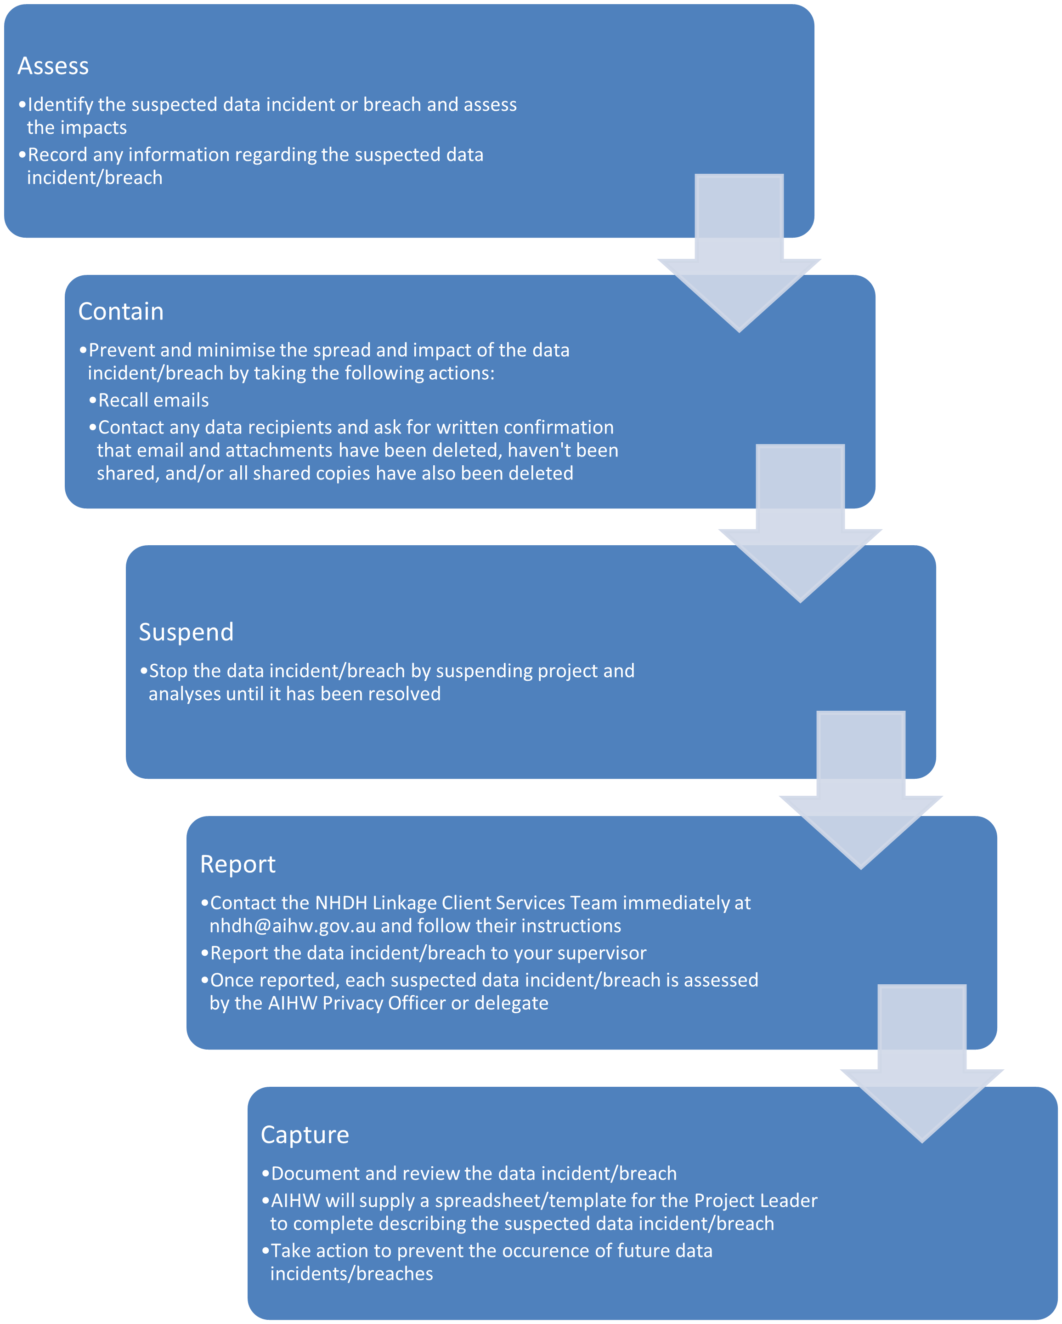

Version control
Version | Date | Author | Change description | Approved
1.0 | 27/10/2025 | Kylie Arnold | Initial draft

