Fact sheet: National Health Data Hub + n Project Model

What is it?
The National Health Data Hub + n (NHDH+n) is a specific project model that allows researchers to enhance their project by linking additional, non-NHDH data collections to the NHDH on a project specific non-enduring basis.
NHDH+n projects are treated the same as customised linkage projects where project proposals are assessed and approved by Data Custodians on a case-by-case basis, including the data flows.
Data for these projects are quarantined in the secure environment on a temporary basis and only accessible by the approved researchers for the approved project. Once the project has been finalised the data will be removed from the NHDH secure environment, and the approved researchers will no longer have access to the data. The data will be securely archived for the seven-year data retention period and then destroyed.

Why is it important?
The NHDH+n project model creates an opportunity for researchers to integrate high-value, population health, medical and social datasets to a national linkage system, supported by streamlined data asset framework, governance and infrastructure. By expanding the depth of analysis beyond what is captured in the data available in the NHDH, researchers can explore complex details about patient’s outcomes and gaps in the health and welfare systems.
Through the integration of external datasets within the existing NHDH platform, researchers can conduct broader analysis using the de-identified NHDH data alongside other relevant de-identified information.

When should a NHDH+n project be requested?
An NHDH+n project should only be requested when researchers need to link additional datasets outside of the existing data offered in the NHDH to answer complex health and welfare related research questions. For example:
- The research questions cannot be addressed using the existing NHDH datasets.
- The external datasets are critical to the project.
- There is a need to examine specific factors regarding health and welfare outcomes.

What can the NHDH+n project model be used for?
The NHDH+n model builds on the AIHW customised linkage program and aims to link and integrate high-value, investigator-initiated health datasets, including (but not limited to):
- registries,
- cohort studies,
- clinical trials,
- government administrative data not currently included in the NHDH,
- additional years of data not currently included in the NHDH.

Can other linkage nodes contribute to the project?
Yes! The AIHW linkage team can work collaboratively with Commonwealth and jurisdictional linkage nodes to determine the most appropriate data flow and linkage strategy for the project. This may involve jurisdictional linkage nodes pre-linking jurisdictional based data before providing the data to the AIHW for inclusion in the NHDH+n project.

How is it governed?
The NHDH+n model is overseen by the NHDH Governance Protocols. Further information can be found on the NHDH governance page.

What is the process?
To initiate a NHDH+n project, a proposal application (including the Feasibility Questionnaire) will need to be completed, detailing the purpose, the methodology and data sources that they would like to link to the NHDH. The AIHW Linkage Client Services Team can assist you through this process and can be contacted via linkage@aihw.gov.au. Further information including application templates are available on the NHDH resources page.
If linkage work is required by state linkage teams, AIHW will liaise with them to determine a feasible data flow.
All contributing data custodians will need to approve the project. The project will also be approved by the NHDH Advisory Committee and all relevant Human Research Ethics Committees, as required by the contributing data custodians.

NHDH+n Approval Process
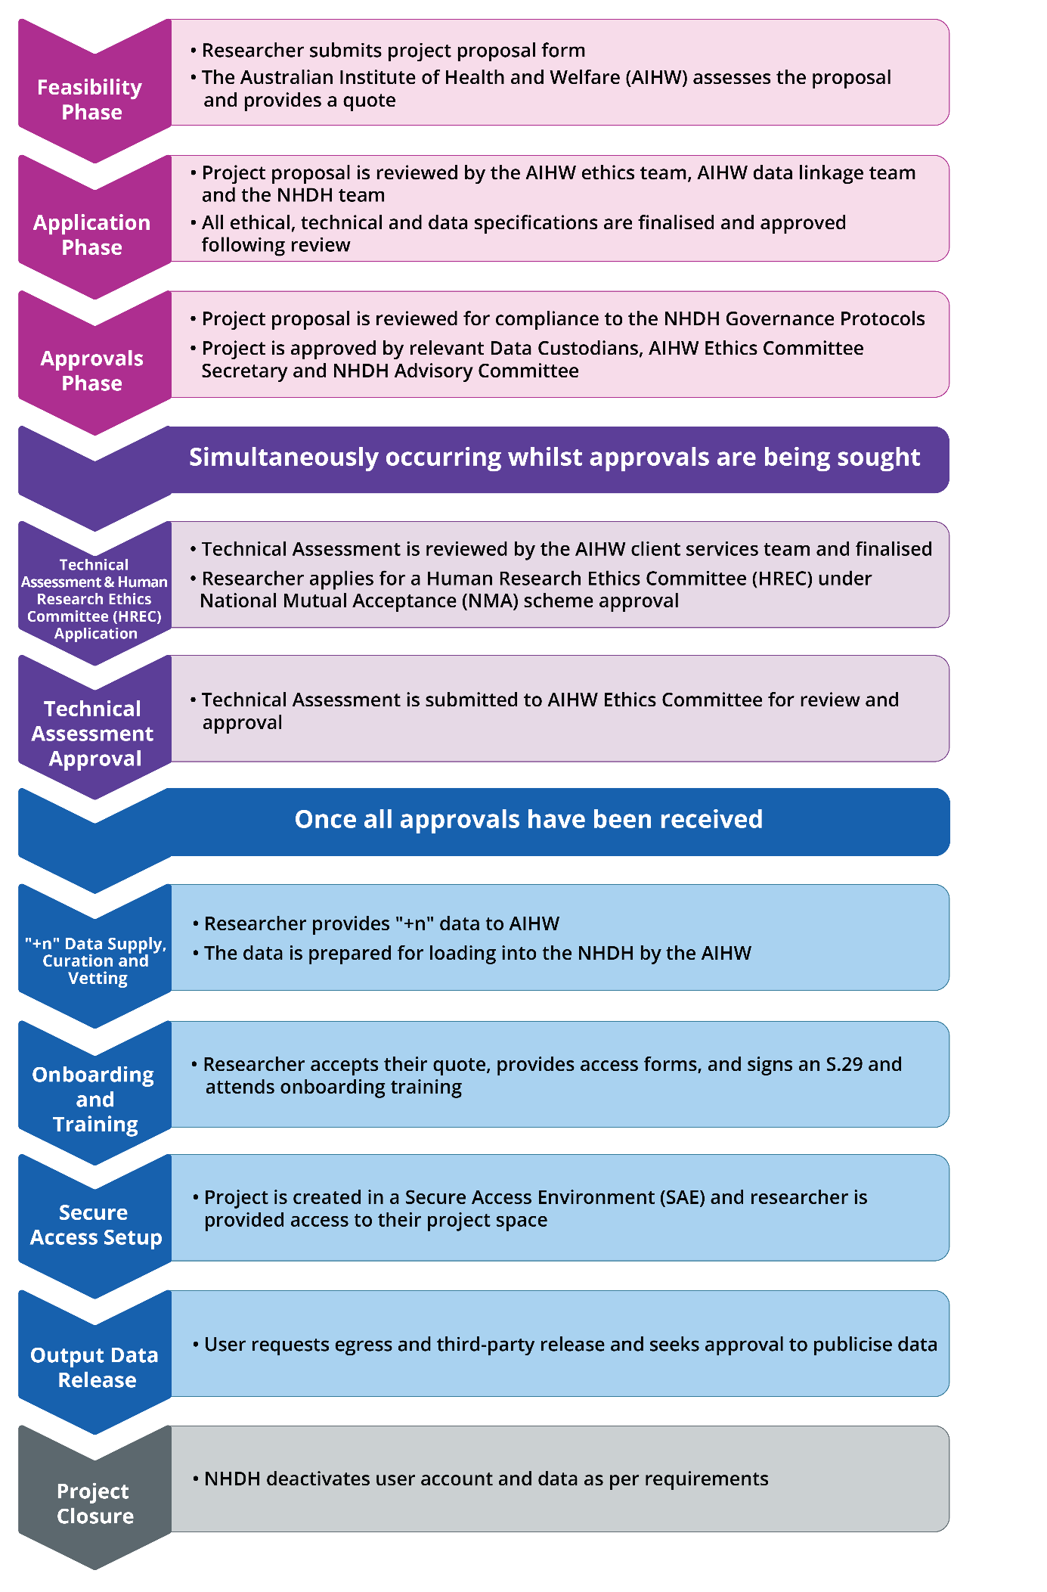

Comparison between the NHDH+n model and the AIHW customised linkage model

Activity | Bespoke linkage approach | NHDH+n approach | Comments
Client engagement | via linkage@aihw.gov.au | via linkage@aihw.gov.au | Researchers approach the same AIHW client services team.
Data flow design | Co-designed in collaboration with state and territory linkage nodes and project partners on a project-by-project basis. | Co-designed in collaboration with state and territory linkage nodes and project partners on a project-by-project basis. | Data flows are negotiated on a project-by-project basis.
Data design | Data can be customised based on research objectives  No limit on how many data sources can be involved in the project, however AIHW would redirect very large state or territory-based linkage projects to the linkage node for that jurisdiction. | Pre-designed data modules are made available to researchers from the NHDH  ‘+n’ data can be designed on a case-by-case basis | Different data design styles used for each approach.  NHDH supports full data module access by researchers facilitating more complex analysis and cohort selection.
Governance & ethics approvals | AIHW Linkage Client Services Unit (LCSU) support researchers through the project governance and ethics approval pathway.  AIHW ethics approval is required, along with any other necessary approval via a Human Research Ethics Committee (HREC). | AIHW LCSU support researchers through the streamlined project governance and ethics approval pathway.  AIHW ethics approval and approval via a HREC under the National Mutual Acceptance scheme is required. | NHDH Researchers are supported through streamlined project governance, reducing time to access data.
Linkage | Depending on the data flow, linkage may be undertaken by either the AIHW or the State or Territory linkage node.  If the project requires linkage to be performed by both AIHW and another linkage node, a linkage map will be provided to the researcher to enable all data in the project can be linked together. | Depending on the data flow, linkage may be undertaken by either the AIHW or the State or Territory linkage node.  If the project requires linkage to be performed by both AIHW and another linkage node, a linkage map can be provided to the researcher to enable all data in the project can be linked together. | Linkage is the same with both approaches, there is no difference.
Merging and data transformations | Depending on the data flow and datasets, merging and transformation tasks will be undertaken by the AIHW or a State and Territory linkage node as appropriate. | Depending on the data flow, merging and transformation will be undertaken by the AIHW or a State and Territory linkage node as appropriate.  All data must have IDs ‘rebadged’ to align with NHDH IDs. Only AIHW can perform this merging task. | Merging and transformation tasks are similar for both approaches.
Testing and Release | Where an AIHW managed Secure Access Environment (SAE) is used, data is released into AIHW custody and vetted before release into the SAE.  Where SURE is used the Curated Gateway facilitates this process. | Only AIHW can load data into the NHDH SAE.  Data is tested and released by AIHW staff before releasing into the SAE and project space.  Utilising SEAD, data is tested and released into AIHW custody and vetted before release into the SAE. This process is facilitated by AIHW SEAD Administrators. | The process for data load is dependent on the SAE utilised.  Where AIHW-management is required by Data Custodians all data is released into AIHW custody and AIHW take responsibility for data vetting.
Secure access environment | De-identified linked datasets are made available to researchers in a quarantined project space in the SURE environment.  Does not support the inclusion of data made available in the NHDH in the project | De-identified linked datasets are made available to researchers in a quarantined project space in the NHDH SEAD environment  Supports the inclusion of data made available in the NHDH in the project. | Different environments are used, however both are highly secure and meet required IT controls.
Output vetting | Researchers are required to comply with the requirements of AIHW and other Data Custodians.  All SAE outputs are reviewed by AIHW for compliance. | Researchers are required to comply with the requirements of AIHW and other Data Custodians formalised through the NHDH governance protocols.  All SAE outputs are reviewed by AIHW for compliance. | Output vetting criteria required to be met by both approaches.  NHDH Governance protocols formalises requirements across custodians with stronger assurances for S/T custodians.
3rd-party release requests | Data Custodians manage researcher compliance with requirements supported by AIHW | AIHW manages researcher compliance with Data Custodian requirements as formalised through the NHDH governance protocols.  Content to be made available publicly needs data custodian approval. | Compliance is managed differently for the two approaches. Through the NHDH, AIHW ensure researcher compliance with requirements and facilitate Data Custodian oversight.

